Dear parents, at Parents Evening some of you asked for recommended titles for the children to read so… 100 Books to Read in Year 4
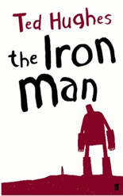
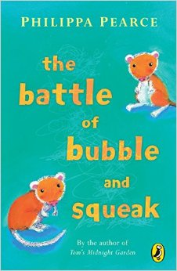
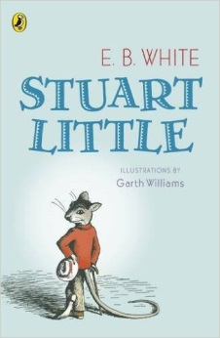
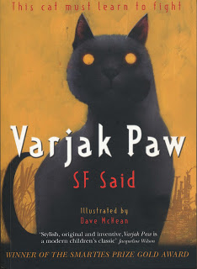
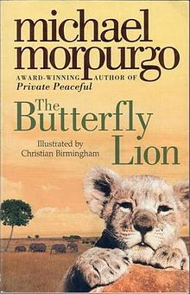
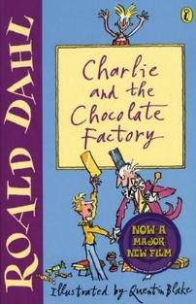
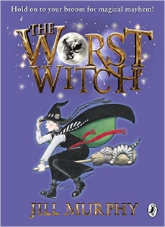
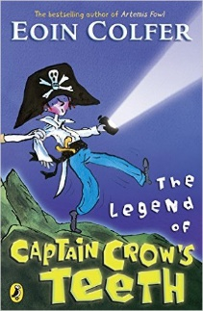
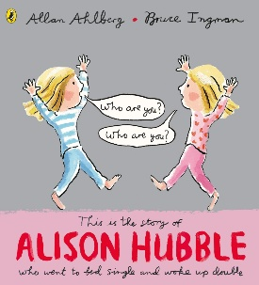
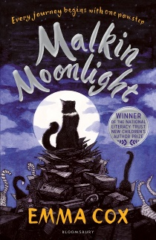
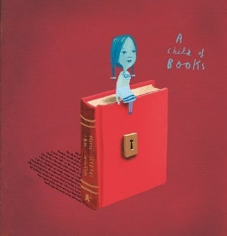
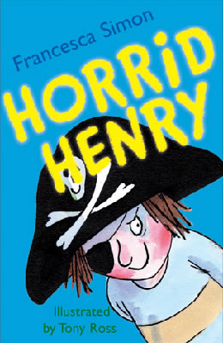
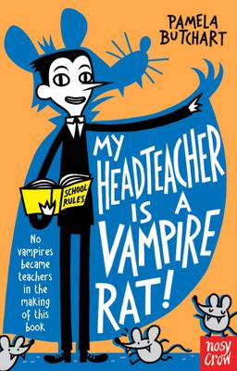
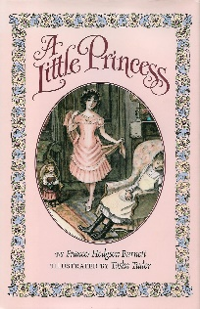
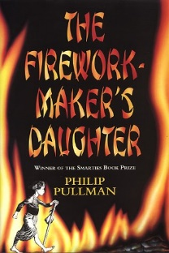
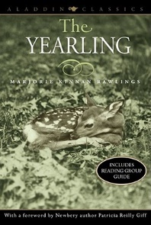
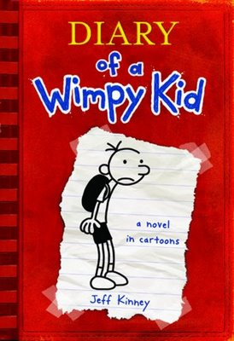
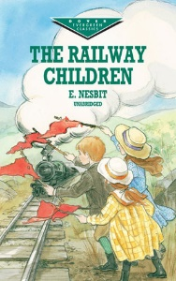
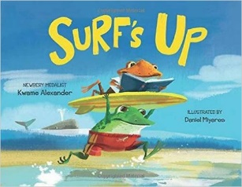
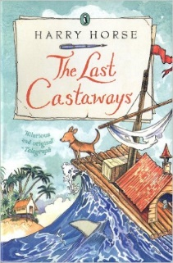
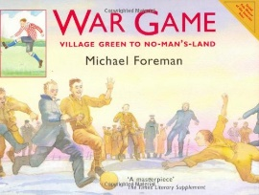
Varjak Paw
S F Said
War Game
Michael Foreman
The Worst Witch
Jill Murphy
The Legend of Captain Crow’s Teeth
Eoin Colfer
Alison Hubble
Allan Ahlberg and Bruce Ingham
Malkin Moonlight
Emma Cox
A Child Of Books
Oliver Jeffers
Horrid Henry
Francesca Simon
My Headteacher is a Vampire Rat
Pamela Butchart
The Iron Man
Ted Hughes
A Little Princess
Frances Hodgson Burnett
The Firework-Maker’s Daughter
Phillip Pullman
The Yearling
Marjorie Kinnan Rawlings
The Railway Children
E Nesbit
Diary Of A Wimp Kid
Jeff Kinney
Surf’s Up
Kwame Alexander
The Last Castaways
Harry Horse
The Battle of Bubble and Squeak
Phillips Pearce
Stuart Little
E B White
The Butterfly Lion
Michael Morpurgo
Charlie and the Chocolate Factory
Roald Dahl

