100 Books To Read In Year 5 and 6
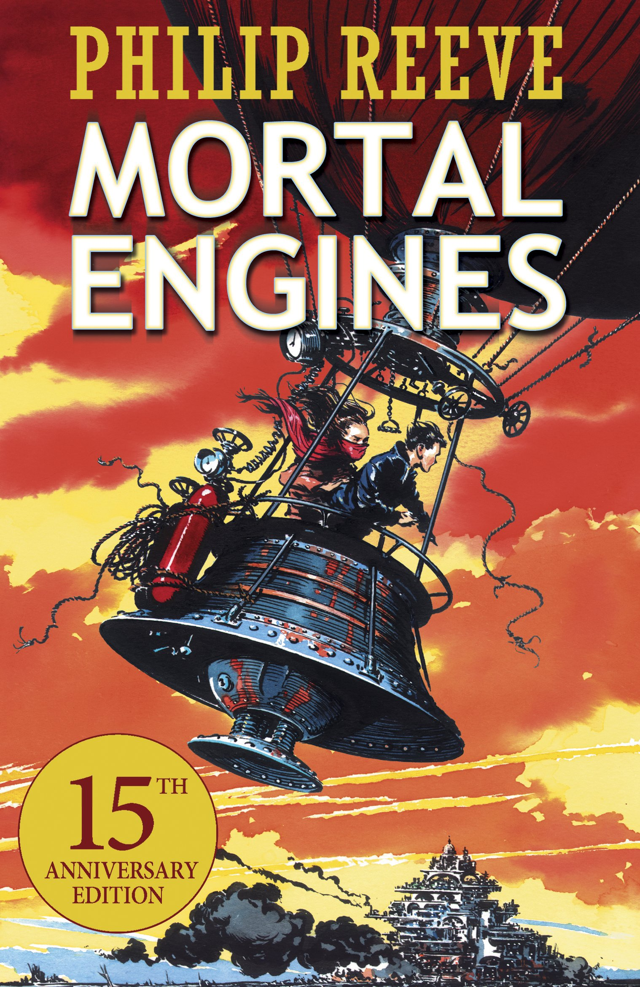
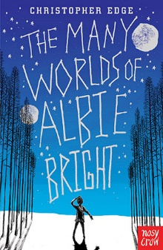
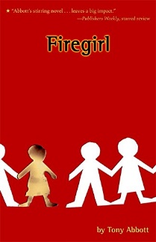
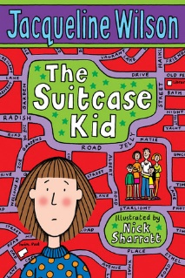
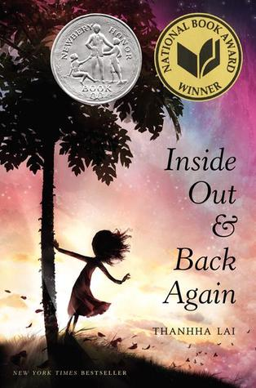
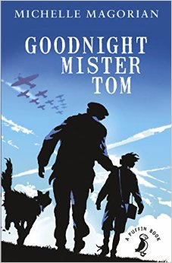
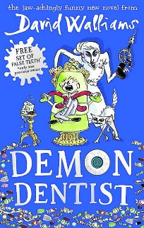
Here are 100 recommended books for children in Year 5 and 6 to read.
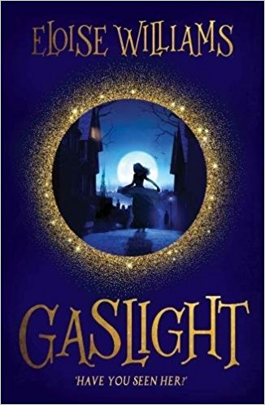
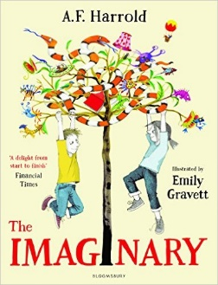
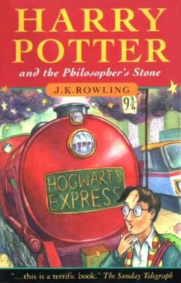
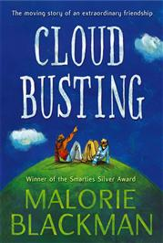
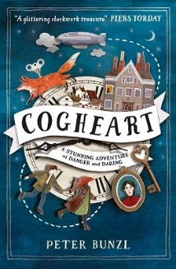
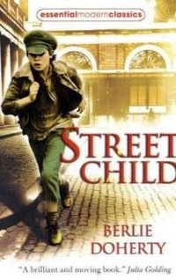
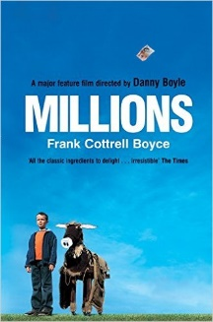
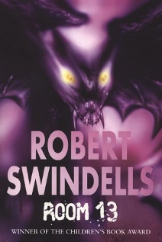
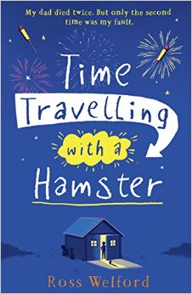
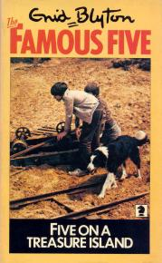
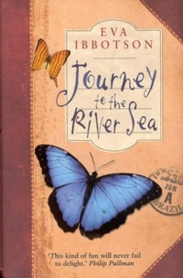
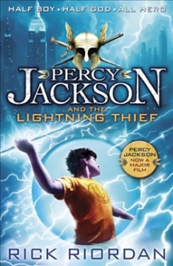
v
Five On A Treasure Island
Enid Blyton
The Imaginary
A F Harold
Harry Potter and the Philosopher’s Stone
JK Rowling
Gaslight
Eloise Williams

Cloud Busting
Malorie Blackman
Cogheart
Peter Bunzl
Street Child
Berlie Doherty
Millions
Frank Cottrell-Boyce
Inside Out and Back Again
Thannha Lai
Kick
Mitch Johnson
Room 13
Robert Swindells
Time Travelling With a Hamster
Ross Welford
Journey to the River Sea
Eva Ibbotson
The Graveyard Book
Neil Gaiman
Percy Jackson and the Lightning Thief
Rick Riordan
The Many Worlds of Albie Bright
Christopher Edge
Firegirl
Tony Abbott
Mortal Engines
Philip Reeve
The Suitcase Kid
Jacqueline Wilson
Goodnight Mister Tom
Michelle Magorian
Demon Dentist
David Walliams

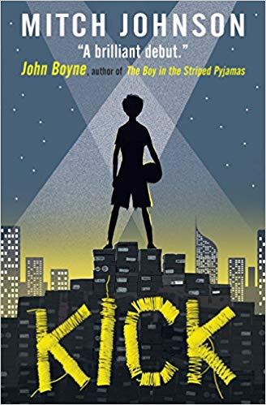
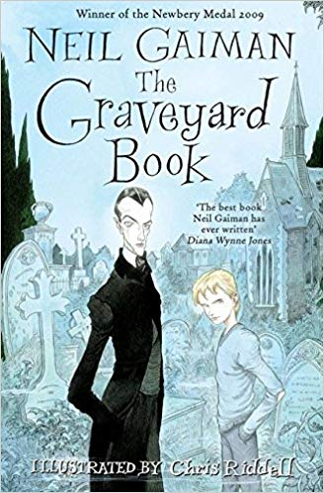

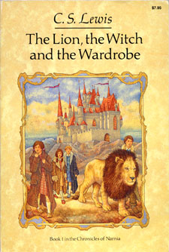
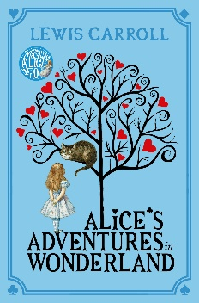
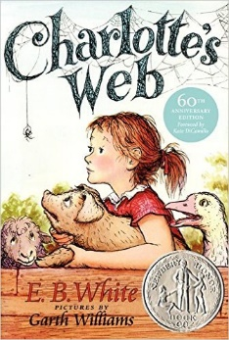
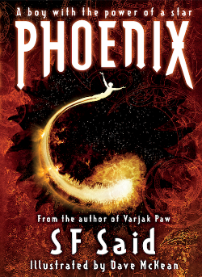
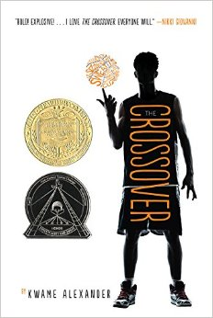
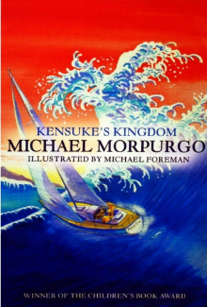
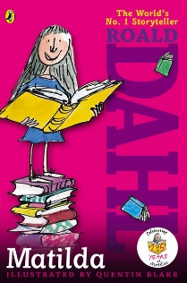
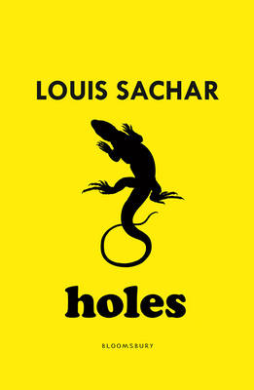
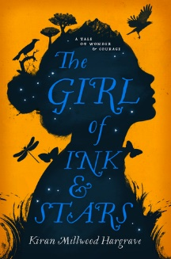
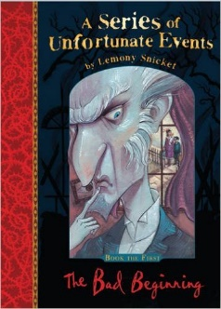
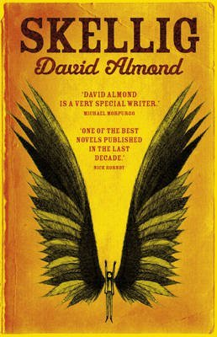
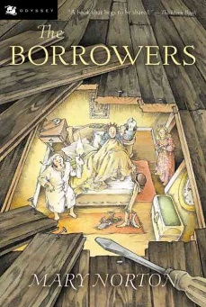
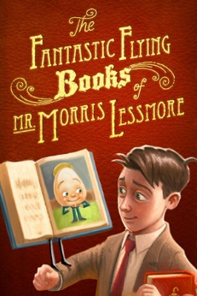
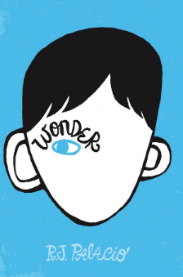
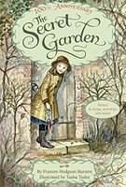
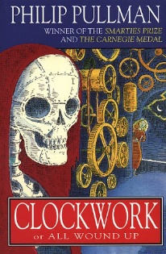
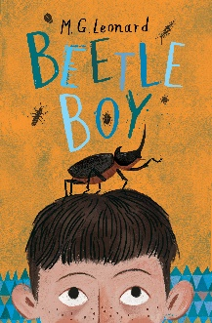
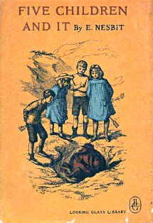
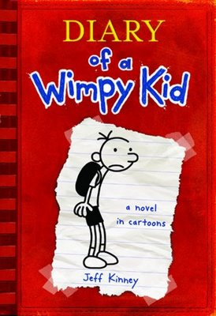
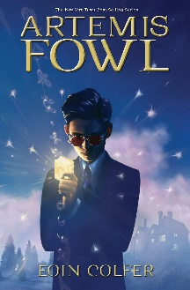
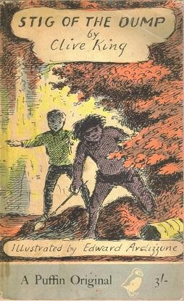
Holes
Louis Sachar
The Girl of Ink and Stars
Kiran Millwood Hargraves
A Series of Unfortunate Events
Lemony Snickett
Skellig
David Almond
The Fantastic Flying Books of Mr Morris Lessmore
William Joyce
The Borrowers
Mary Norton
Wonder
RJ Palacio
The Crossover
Kwame Alexander
The Secret Garden
Frances Hodgson Burnett
Clockwork
Phillip Pullman
Beetle Boy
M G Leonard
Five Children and It
E Nesbit
Diary Of A Wimp Kid
Jeff Kinney
Artemis Fowl
Eoin Colfer
Stig Of The Dump
Clive King
The Lion, The Witch and The Wardrobe
C S Lewis
Alice’s Adventures In Wonderland
Lewis Carroll
Charlotte’s Web
E B White
Phoenix
S F Said
Kensuke’s Kingdom
Michael Morpurgo
Matilda
Roald Dahl

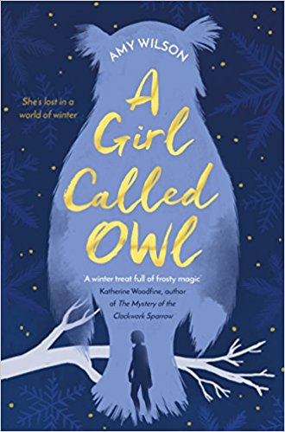
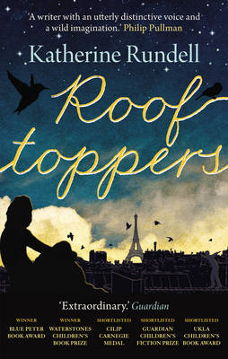
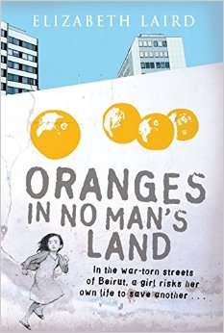
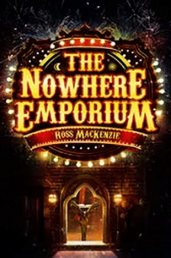
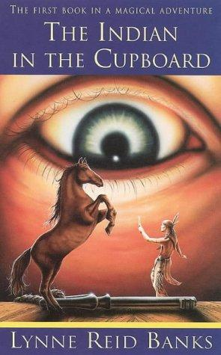
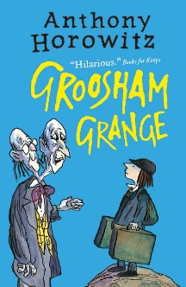
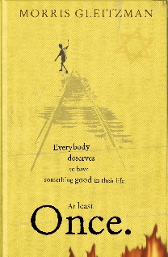

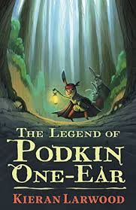
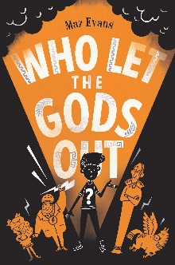
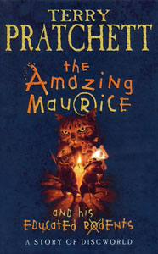
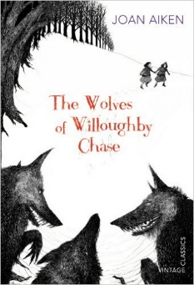
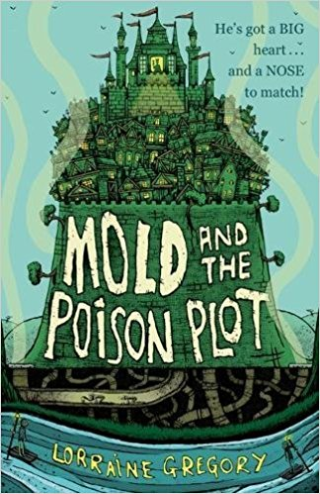
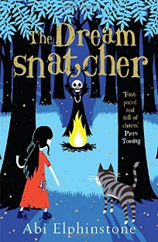
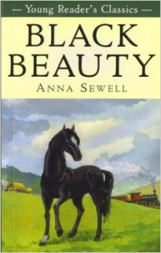
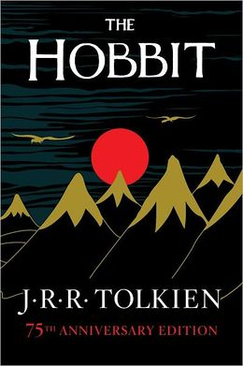
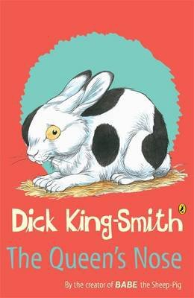
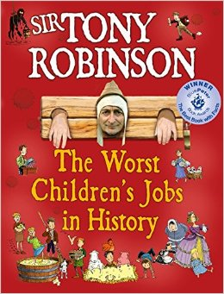
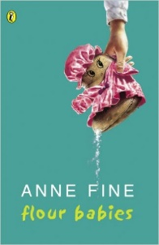
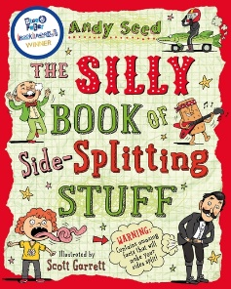
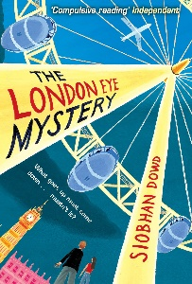
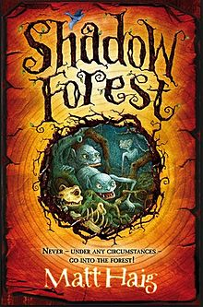
Who Let The Gods Out?
Maz Evans

The Amazing Maurice and his Educated Rodents
Terry Pratchett
The Wolves of Willoughby Chase
Joan Aiken
The Silly Book of Side-Splitting Stuff
Andy Seed
Black Beauty
Anna Sewell
The Hobbit
JRR Tolkien
The Queen’s Nose
Dick King-Smith
The Worst Children’s Jobs In History
Tony Robinson
The Indian In The Cupboard
Lynne Reed Banks
Flour Babies
Anne Fine
Mold and the Poison Plot
Lorraine Gregory
The Dreamsnatcher
Abi Elphinstone
The London Eye Mystery
Siobhan Dowd
The Legend of Podkin One Ear
Kieran Larwood
Shadow Forest
Matt Haig
A Girl Called Owl
Amy Wilson
Rooftoppers
Katherine Rundell
Oranges in No Man’s Land
Elizabeth Laird
The Nowhere Emporium
Ross Mackenzie
Groosham Grange
Anthony Horowitz
Once
Morris Gleitzmann

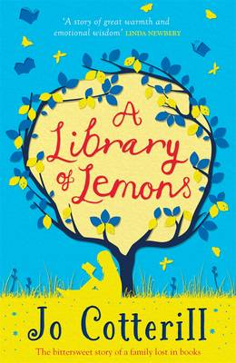
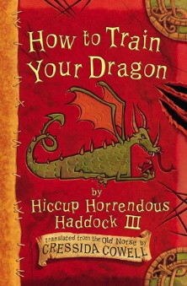
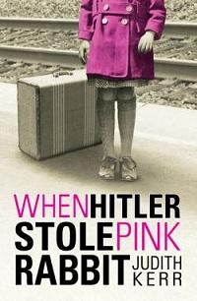
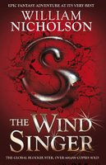
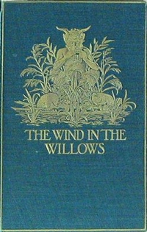
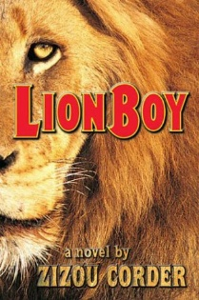
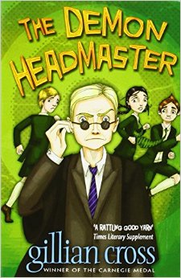
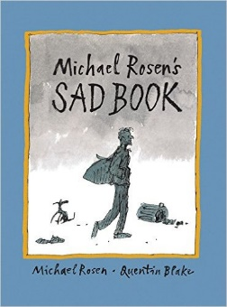
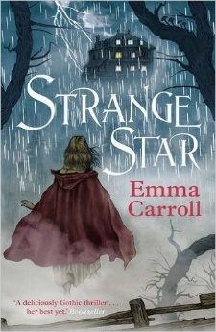
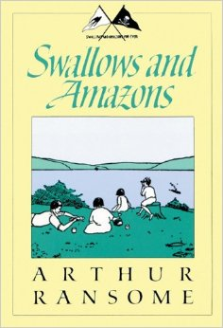
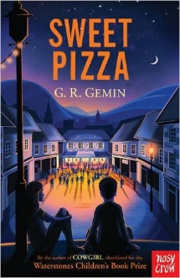
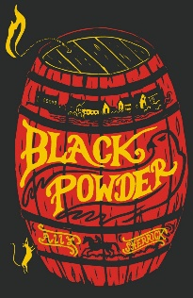
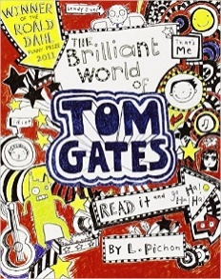
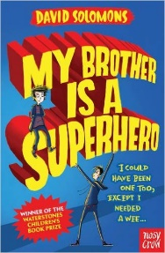
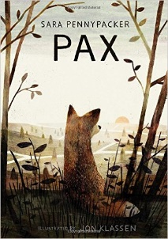
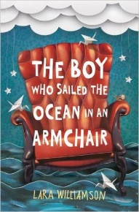
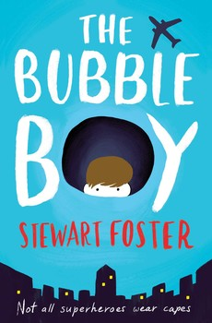
Pax
Sara Pennypacker
Ballet Shoes
Noel Streatfeild
The Arrival
Shaun Tan
Sad Book
Michael Rosen

A Long Walk To Water
Linda Sue Park
Strange Star
Emma Carrooll
Swallows and Amazons
Arthur Ransome
Sweet Pizza
G R Gremin
The Wind in the Willows
Kenneth Grahame
Black Powder
Ally Sherrick
The Brilliant World of Tom Gates
Liz Pichon

Liz Pichon
My Brother is a Superhero
David Solomons
The Boy Who Sailed the Ocean in an Armchair
Lara Williamson
The House With Chicken Legs
Sophie Anderson
The Bubble Boy
Stewart Foster

A Library of Lemons
Jo Cotterill
How to Train Your Dragon
Cressida Cowell
When Hitler Stole Pink Rabbit
Judith Kerr
The Wind Singer
William Nicholson
LionBoy
Zizou Corder
The Demon Headmaster
Gillian Cross

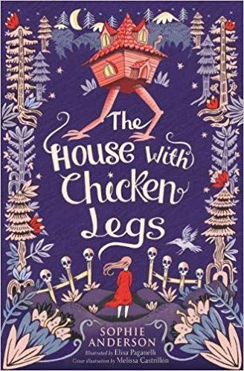

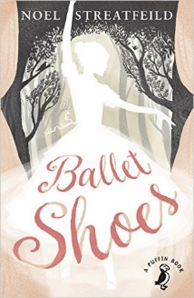
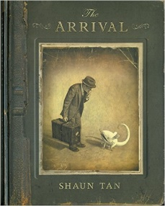
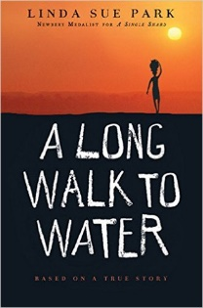

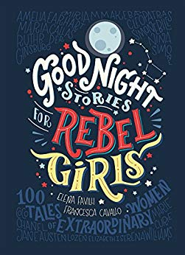
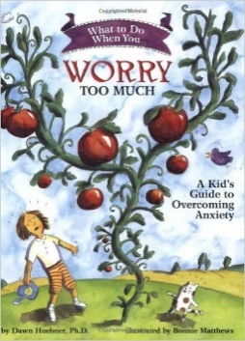
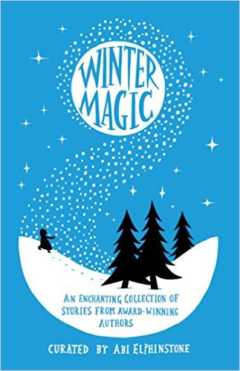
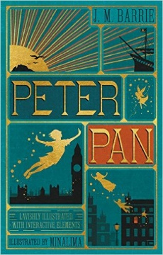
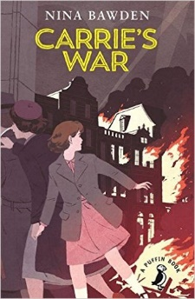
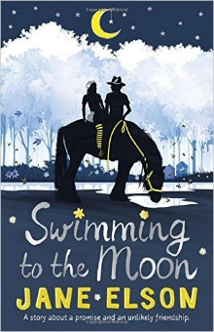
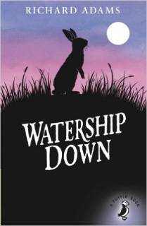
Skullduggery Pleasant
Derek Landy
The Wonderful Wizard of Oz
L Frank Baum
The Miraculous Journey of Edward Tulane
Kate DiCamillo
Carrie’s War
Nina Bawden
The Goldfish Boy
Lisa Thompson
101 Poems for Children
Carol Ann Duffy

Liz Pichon
Howl’s Moving Castle
Diana Wynne Jones
There May Be A Castle
Piers Toarday
The Invention of Huge Cabret
Brian Selznick
What to Do When You Worry Too Much
Dawn Huebner
Winter Magic
Stories by Various Authours
Peter Pan
JM Barrie
Swimming to the Moon
Jane Eslson
Watership Down
Richard Adams

Goodnight Stories For Rebel Girls
Elena Favilli and Francesca Cavallo
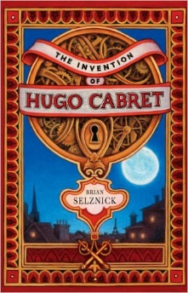
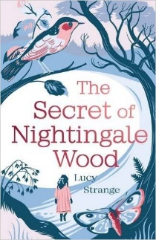
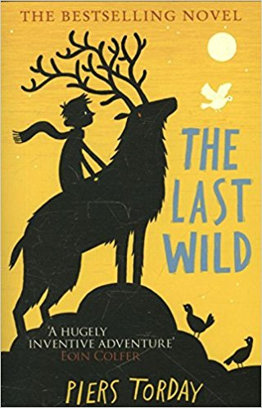
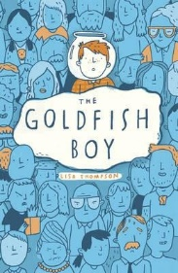
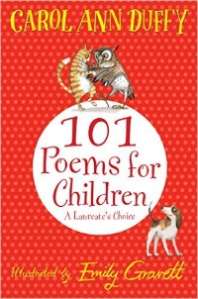
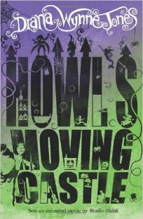
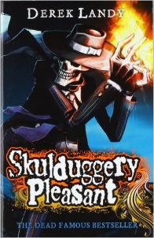

The Secret of Nightingale Wood
Lucy Strange



