Context
Christ Church is a one form entry, voluntary aided, Church of England primary school located on the edge of Colne town centre. We are smaller than average primary school.
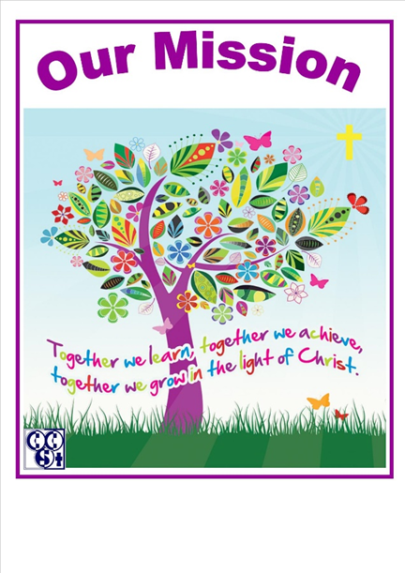
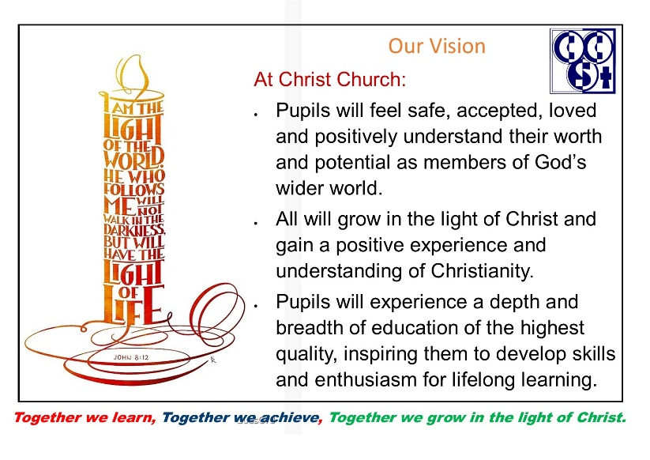




References
- HM Government home office 07.06.2011 Policy paper: Prevent Strategy 2011 Ref: ISBN 9780101809221 Crown Copyright.
- Counter Extremism Strategy : October 2015
- Terrorism Act 2006
- Rowe, D (2001) A brief Guide – Democracy in Schools and the Local Community.
- OFSTED Inspection report: Christ Church C of E Primary School March 2023
- SIAMS National Society Statutory Inspection of Anglican Schools SIAMS report November 2017

From July 2015, the Counter Terrorism and Security Act placed a statutory duty on all schools to prevent people being drawn into terrorism and extremism.
Definition of extremism
Extremism is the vocal or active opposition to our fundamental values, including democracy, the rule of law, individual liberty and the mutual respect and tolerance of different faiths and beliefs. We also regard calls for the death of members of our armed forces extremist. (Counter Extremism Strategy October 2015)
Definition of terrorism
Terrorism is defined as action designed to influence the government, intimidate the public, Its purpose is to advance a political, religious or ideological cause that endangers or causes serious violence or harm to people, property or seriously disrupts or interferes with an electronic system. (Terrorism Act 2006)
In School…
Since 2012, it has been required by law for all educationalists to uphold fundamental British Values.
The government set out its definition of British Values in the 2011 Prevent Strategy. The Department for Education state that there is a need…
“to create and enforce a clear and rigorous expectation on all schools to promote the fundamental British values of democracy, the rule of law, individual liberty and mutual respect and tolerance of those with different faiths and beliefs.”
At Colne Christ Church CE Primary School we are committed to upholding these values alongside our Christian core values of love, forgiveness and reconciliation. We ensure that they are reinforced regularly through teaching and learning which has a clear focus on enabling all children’s spiritual, moral, social and cultural development. We are aware Inspectors will assess and verify the breadth and balance of the school’s curriculum and whether it is likely to promote preparation for, and an appreciation of, life in modern Britain.
OFSTED reported “Leaders have ensured that the curriculum is ambitious for all pupils, including pupils with SEND”. (OFSTED Report March 2023)
As part of our safeguarding duties we will protect pupils from the risk of radicalisation (see school safeguarding and Child Protection and Online Safety policies). Staff and Governors will also access PREVENT awareness training in this regard. Indeed, OFSTED commented “Pupils… are clear that they should treat everyone with respect regardless of differences, for example race or religion”. (OFSTED Report March 2023)
Modern Britain
Colne Christ Church CE Primary is committed to serving its local, national and international community. We recognise the multi-cultural, multi faith and ever-changing landscape of the United Kingdom. As a Church school, we actively promote virtues, ethics and the ‘Values for Life’ which shape our children's character and moral perspective, through the teachings of the Church and within our worship. We encourage children and staff to witness these values in their everyday lives. The teachers’ standards expect teachers to uphold public trust in the profession and maintain high standards of ethics and behaviour, within and outside school. This includes not undermining fundamental British values. We are confident that our continued focus on the Gospel will give our children the necessary awareness of what it means to be a good citizen in Britain today and embed in them the building blocks of a future successful and productive life. We teach about democracy, civic responsibility, rules and laws, the monarchy, equality, values and virtues through ‘Roots and Fruits’ and ‘Values for Life’, the national curriculum including PHSCE, environmental awareness and the understanding of other faiths. The Staff and Governors use every opportunity to promote the rich ethos of our school and seek to serve all so that all feel a sense of belonging and welcome.
Democracy
Respect for democracy, democratic participation and active involvement of all pupils is evident across the school. We aim to provide pupils with a broad general knowledge of and promote respect for public institutions and services. Our aim is to teach pupils how they can influence decision making through the democratic process. Consequently we strive to provide children, parents and staff with many opportunities for their voices to be heard in school. We have an active school council whose members are chosen / elected by the children. The school councillors work alongside the senior leaders in school to enable them to influence and make decisions in matters which affect their lives within the school. Representatives of our school council also take part in Colne Junior Council (made up of representatives from other local schools). This reflects our British electoral system and demonstrates democracy in action.
In Early Years, as part of the focus on self-confidence and self-awareness, as cited in Personal, Social and Emotional Development, staff encourage children to see their role in the bigger picture, encouraging children to know their views count, value each other’s views and values and talk about their feelings, for example when they do and do not need help. Democracy in action is demonstrated through adult and child inspired topic selections and all children’s ideas are actively sought through shared sessions where activities and opportunities to develop enquiring minds are promoted.
Our school behaviour policy involves rewards and sanctions which can facilitate understanding of wider issues within the context of learning about the values on which our society is founded and our system of democratic government. Children work together to agree the rewards associated with ‘good work’ and the rights associated with these. They are listened to and taught to listen carefully and with concern to each other, respecting the right of every individual to have their opinion and voices heard.
In our recent SIAMS inspection (Nov 2017) it was noted that “The school’s approach to behaviour management is rooted in its identified Christian values of love, forgiveness and reconciliation. This is fully recognised by pupils… As a result, pupils’ behaviour and attitudes are exemplary”.
Our children make decisions together. This links to our mission statement and ensure that they:

- have a say in what happens through School Council and Worship Group
- contribute to our topics and influence activities and changes to our school resources.

Rules and Law
OFSTED said ‘Staff have high expecations of pupils’ behaviour. They apply the behaviour policy consistently well. Pupils behave well around the school and are attentive in lessons. They are polite and respectful to staff and each other.’ (Christ Church OFSTED Report March 2023)
The importance of rules and laws, whether they be those that govern our class, school or our country, are referred to and consistently reinforced throughout regular school days, as well as when dealing with behaviour and through Collective worship. Pupils are taught to have respect for the basis on which the law is made and how the law is applied in England. We aim to teach children the value and reasons behind laws, that they govern and protect all of us, the responsibilities that this involves and the consequences when laws are broken. ‘Values for Life’ are a basis for how we should live our lives and we use the example of Christ when dealing with behaviour that is not acceptable. In addition to this, planned visits from the police and fire service and appreciation of rules in sport are regular parts of our school calendar and help reinforce this message. We promote outstanding behaviour and this is sustained through our behaviour policy which is based on Jesus’ teachings, thus ensuring that school rules and expectations are clear and fair and all our pupils understand that rules are there to protect us just as living under the rule of law protects all individuals in society.

Our children understand why rules are important:

- We develop fair rules for our classrooms to develop order.
- We understand that rules are developed to support and prepare us for the world of work and life in general.

Individual Liberty
We actively promote and model individual liberty by supporting children to develop their self-knowledge, self-esteem and self-confidence eg. through our Christian ethos, our way of treating people, by investing heavily in meeting the needs of all of the children, by providing equality of opportunity and by knowing and understanding the needs of all of the children. Pupils are encouraged to know, understand and exercise their rights and personal freedoms and exercise them safely, for example through Online Safety, Life Education lessons and menu choices. Within school, children are actively encouraged to make choices, knowing that they are in a safe and supportive environment. We reassure children to take responsibility for their behaviour as well as knowing their rights eg. through linking rights with responsibilities and by having a fair and consistent approach to the behaviour policy. Whether it is promoted through choice of challenge, how they record or by individual participation in our extra-curricular activities, children are given the freedom to make choices. We welcome freedom of speech through pupil participation, while ensuring protection of vulnerable pupils and challenging stereotyping of others. We implement and actively promote a strong anti-bullying culture and invite visitors into school to support our anti bullying policy.


Our children demonstrate freedom for all:
- We make our own choices and understand the rewards or consequences of our own actions.

Mutual Respect: (also see Behaviour Policy)

Our behaviour policy revolves around our core values of Love, Forgiveness and Reconciliation. Pupils are expected to show mutual respect towards everything and everyone, regardless of individual differences, at all times. Indeed our school rule is “…to respect and show courtesy and kindness to all people, at all times”. This is achieved through enhancing children’s understanding of their place in a culturally diverse society and by giving them opportunities to experience such diversity. We actively promote and model respect and tolerance by promoting respect for individual differences through Collective Worship, the RE curriculum, multicultural, multi-faith weeks and activities and through our ethos. All children, adults and visitors are expected to behave respectfully and we will challenge anybody who displays prejudicial or discriminatory behaviours. Pupils take part in worship and class discussions related to what this means and how it is shown. For our early years children, much of our curriculum is aimed at developing personal and social skills which enhance their learning, including knowing about similarities and differences between themselves and others and among families.

SIAMS inspection report ‘The strong Christian leadership of the headteacher is supported wholeheartedly by staff and governors. This results in the school’s Christian vision ‘Together we learn, together we achieve, together we grow in the light of Christ’ being fully understood and lived out faithfully by all members of the school community’.

`Relationships at all levels are exceptional and rooted in the school’s core Christian values of love, forgiveness and reconciliation. The school is highly proactive in its approach to the pastoral care of children and families resulting in support which responds to need with love and compassion’. (November 2017)

Our children treat others as they want to be treated:
- We work together to help one another.
- We respect each other’s physical space
- We respect each other’s contributions to discussion
- We take on group roles to support the learning of our peers

Tolerance of those with different faiths and beliefs

We will help pupils to acquire an understanding of and respect for their own and other cultures and ways of life. This is achieved by enhancing pupils’ understanding through the curriculum, of their place in a culturally diverse society and by giving pupils opportunities to experience such diversity. Worship, Assemblies and discussions involving identifying and combating discrimination, prejudices and prejudice- based bullying have been followed and supported by learning in RE and PHSCE. We organise visits to places of worship, openly discuss and celebrate the differences between people such as differences of faith, ethnicity, disability, gender and different family situations. We encourage our children to participate in a wide range of events and provide opportunities for pupils to serve the wider community in order to nurture tolerance and harmony, understanding and respect between all members of our society.

Our children enjoy learning about different faiths and cultures:
- We listen carefully to other peoples points of view.
- We investigate traditions, customs and religious practices and how they strengthen the multi-cultural world we live in.
- We discuss how diversity makes us what we are today.

Actions Going Forward
- To enhance links with different Faith Centres and develop our links with other schools of multi faiths and cultures.
- To further develop Collective Worship to reflect Christian and British Values.
- To increase understanding of what “British Values” means amongst staff and children in the context of “Modern Britain”.

The statement will be reviewed every 3 years
Signed: (Head teacher)
Signed: (Chair of Governors)
Date: 13.10.2023.
Next review: September 2026

