Christ Church C of E Primary School
Updated by Julie Rayner
January 2023
Agreed by Governors:
To be reviewed: January 2025
Reading Policy

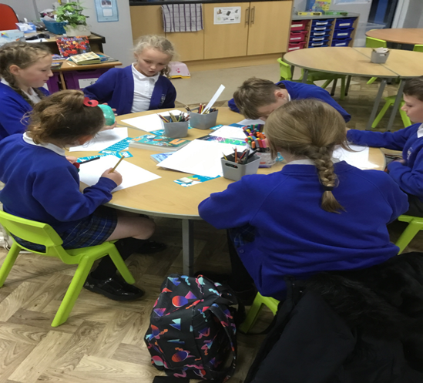

Table of Contents
School Vision and context…………………………………………………………………………………………………………………………………………….. 1
Foundation Stage 1
KS1 2
KS2 2
The Teaching of Reading 2
Whole Class Guided Reading Opportunity to: 2
Small Group Guided Reading 3
Reading at home 3
Monitoring and Review 4

‘Together we learn, together we achieve, together we grow in the light of Christ’

School Vision

At Christ Church:
- Pupils will feel safe, accepted, loved and positively understand their worth and potential as members of God’s wider world.
- All will grow in the light of Christ and gain a positive experience and understanding of Christianity.
- Pupils will experience a depth and breadth of education of the highest quality, inspiring them to develop skills and enthusiasm for lifelong learning.

School Aims

At Christ Church we endeavour to provide this by:

- Ensuring a safe learning environment
- Providing a high-quality, broad and balanced curriculum
- Upholding outstanding standards of behaviour
- Providing a family-feel nurturing and caring environment
- Develop self-belief, resilience and determination to succeed
- Creating opportunities for all abilities to try new things and make discoveries
- Embracing new technology
- Promoting logical and creative thinking skills
- Encouraging independence, democracy and responsibility
- Promoting curiosity and enthusiasm
- Encouraging mutual respect for others
- Working with and learning from others
All of this is achieved while working in collaboration to fully develop strong and positive partnerships with parents and the wider community.

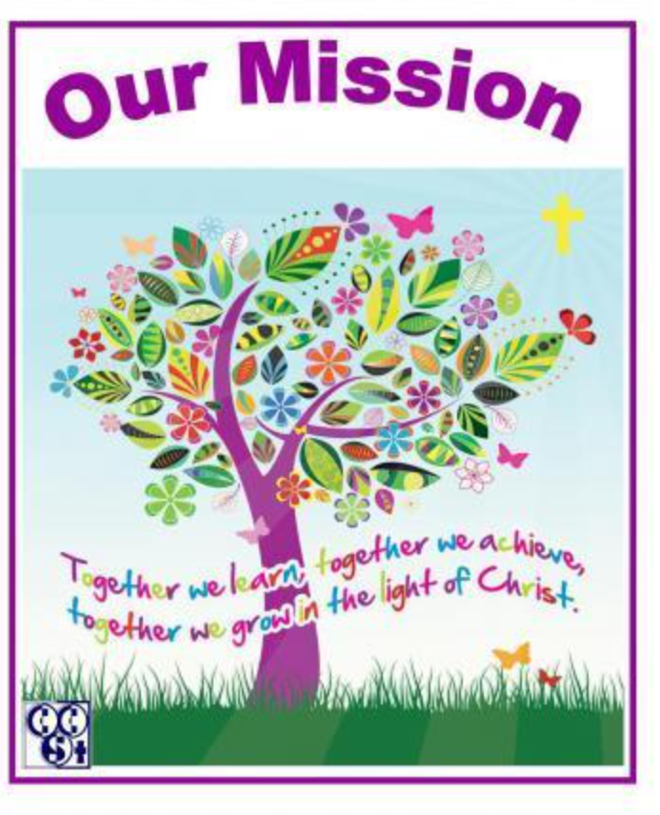

The context of our school
Christ Church C of E Primary School is a one form entry school on the edge of Colne. We believe that it is essential that our approach to teaching phonics and reading is accessible to all learners, regardless of background and ability, and that it promotes and fosters a life-long love of reading from the very beginning of their school journey.

Intern of this policy and reading curriculum: To become an outstanding reading school. We will:
- Place reading and books at the centre of the curriculum.
- Recognise that being able to read well is a key life skill for children, whatever their background.
- Believe that every child can learn to read with the right teaching and support.
- Acknowledge that not all children will have the opportunity to develop a love of reading at home, so this has to be taught and encouraged at school, just like any other area of the curriculum.
- Build time for all children to read independently, read aloud and be read to during the school day.
- Develop a coherent whole - school strategy for promoting reading for pleasure.
- Ensure all classes have a class book which is read aloud for 10 minutes at the end of each day.
- Arrange visits to the local library.
- Arrange at least 3 Whole School themed reading days per year during which the whole school enjoy activities based around the same author’s books.
- Invite authors and poets into school to inspire and motivate the pupils.
- Spend money and time to support reading, including buying books and developing the school environment to support reading.
- Believe that every teacher should be an advocate for reading.
- Believe that every child should be an advocate for reading through the opportunity to be whole school reading ambassadors.
- Devote time to training staff so they are equipped to support children’s enjoyment of reading.
- Involve parents to ensure the culture of reading that the school has developed extends into the home and support parents in their understanding of age related expectations.
- To support and equip children with the phonic skills to decode words through Little Wandle lessons in order to read at an age appropriate level.

At Christ Church C of E Primary School, all children learn to love books and the school is prepared to make this an absolute priority.

Foundation Stage
- Baseline the children within the first six weeks of the new school year.
- Daily 15-minute discrete phonics session. (Little Wandle)
- Children assessed for Little Wandle every 6 weeks and based on this, differentiated phonics support is provided.
- After week 3 the children who are blending - 2 x GR sessions per week (per child).
- Home reading diaries monitored.
- Whole class reading sessions at least twice a week.
- Individual reading with an adult in school, at least once per week (three times for the bottom 20%).
- Keyword practice with an adult in school.
- Targeted children and those working below age related expectations to have access to a suitable intervention.

KS1
- Daily 20-minute discrete phonics session. (Little Wandle)
- Once children have successfully passed the Year 1 Phonics Screening Test, children access a daily spelling lesson. Phonics (Little Wandle) will continue if gaps are present.
- Children assessed for Little Wandle every 6 weeks.
- 3x Whole Class GR sessions.
- Individual reading with an adult in school, at least once per week (three for the bottom 20%).
- Home Reading Diaries monitored.
- Targeted children and those working below age related expectations to have access to a suitable intervention.

KS2
- Discrete phonics intervention sessions in LKS2 (Little Wandle Rapid Catch up Intervention), according to need.
- 3 x Whole Class GR sessions per week. These sessions will always incorporate teaching and developing reading fluency skills and will also include modelled, shared and independent reading skills practice.
- Those children who need extra support in their reading will access individual reading with an adult in school, at least three times per week.
- In place of GR, teachers should spend one week of every term hearing individual readers and or / completing YARC reading fluency assessment with children who are below their expected book band.
- Targeted children and any children working below age related expectations to have access to a suitable intervention.

The Teaching of Reading

Reading at Christ Church C of E Primary School is taught through a variety of cohesive structures:

In EYFS, children begin their reading journeys and the focus is on developing an early love of reading and books alongside the acquisition of early reading and decoding skills: lessons focus on frequent opportunities for shared stories, vocabulary development sessions, discrete phonics teaching together with small group guided sessions and individual reading opportunities.

In KS1 and KS2 the core principals of ‘ Becoming a Fluent Reader’ are integrated into the structures of Whole Class Reading, Whole Class Reading for pleasure books, 1:1 Reading and comprehension lessons (from Year 2).
We are committed to ensuring every child becomes a fluent reader and explicitly model and teach strategies to develop these skills; we teach our children to learn to read and then focus on teaching them the skills needed to read to learn.

Whole Class Guided Reading Opportunity to:

- Model what a good reader / comprehender looks like.
- Teach the content domains or a key comprehension skill through engaging whole class texts ( we do use Reading Vipers as a focus for this).
- Teach and model the core principles of being an ‘Active Reader’.
- Teach and model key comprehension strategies that link to the reading Content Domains.
- Provide opportunity for collaborative exploration of key reading / comprehension skills.
- Teach, model and practice effective interrogation of a text.
- Model how to approach and frame answers to comprehension questions.
- Model effective text marking and other strategies that will help them to fully understand a text.

Small Group Guided Reading

A timetable is in place for Year 1 which the children to have 2 x 15 minutes Guided Reading per week. During these sessions, all reading groups have the support of an adult who guides them through the reading and understanding of age appropriate and engaging texts. Opportunity for children to:

- Emulate the good modelling provided in GR.
- Apply what is taught in Whole Class GR, in a smaller, more focused ability-group
- Use the language modelled in whole class teaching.
- Engage in open debate / give and justify their opinions / discuss the impact of the text in a smaller group setting.
- Display their ability to read actively: naturally noticing where inferences can be made noticing keywords and using them to spontaneously predict / infer etc. summarising and synthesising what they read independently marking texts in a way that will help them gain meaning / address a given content domain.
Opportunity for adults to:
- Make formative assessment of children’s progress
- Complete reading attainment trackers to indicate each child’s attainment and any gaps to be addressed in future teaching.

Assessing reading
Once our children can decode words with automaticity and accuracy, we continue to further develop their ability to read fluently. This fluency involves continually assessing the children against the flowing components:
- Automaticity (rapid word reading without conscious decoding)
- Accuracy ( often measured as correct words per minute)
- Prosody (expressive, phrased reading)

All of these components are essential in supporting understanding of texts (comprehension).
We use the HERTs For Learning Reading Toolkit to support our assessments of reading from Year 1 (Summer Term) all the way into Year 6. These materials provide a more detailed breakdown ( smaller steps) of the national curriculum reading requirements.
Children currently undertake National Standardised Reading Assessments at the end of KS1 and KS2.

Reading at home

At Christ Church C of E Primary School we value the contribution that parents and carers make to their children’s education. Reading is a key area where home and school can work together to improve children’s skills. As such we ask all parents / carers to listen to their children read on a daily basis. Reading diaries are given to EYFS and KS1 children.

- In EYFS and KS1, 2 home reading books are provided each week.
- Persistent non-reading will result in the Class Teacher contacting parents / carers to reiterate the importance of home reading. The class teacher will also discuss any issues relating to home reading with the parent / carer.
- Persistent non-reading will be referred to the Assistant Head and the Head Teacher.

At Christ Church C of E Primary School, we believe that all pupils can achieve in Reading, both for pleasure and in their comprehension and understanding. We believe through reading, pupils will have a chance to develop culturally, emotionally, intellectually, socially and spiritually.

Linked Policy
Please read this policy alongside the early reading and phonics policy.

Monitoring and Review
This policy will be reviewed by the Headteacher and governing body on an annual basis, who will make any necessary changes and communicate this to all members of staff.

