Christ Church C of E Primary School 



Christmas Reading Challenge
Welcome to our Christmas Reading Challenge, below you will find 12

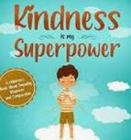
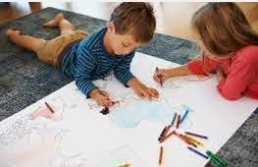
activities to complete during our Christmas Holidays.

Read a book by the Christmas Tree   | Build a den and share a story in it |  |  | 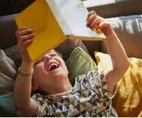  Read a book that makes you laugh
 |  | 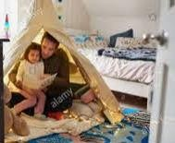
Draw a picture from your favourite book | Read a book about kindness |  |  | Read a book about your favourite animal. What new facts have you found out?
Share a Christmas poem with someone  https://www.panmacmillan.com/blogs/literary/our-favourite-christmas-poems  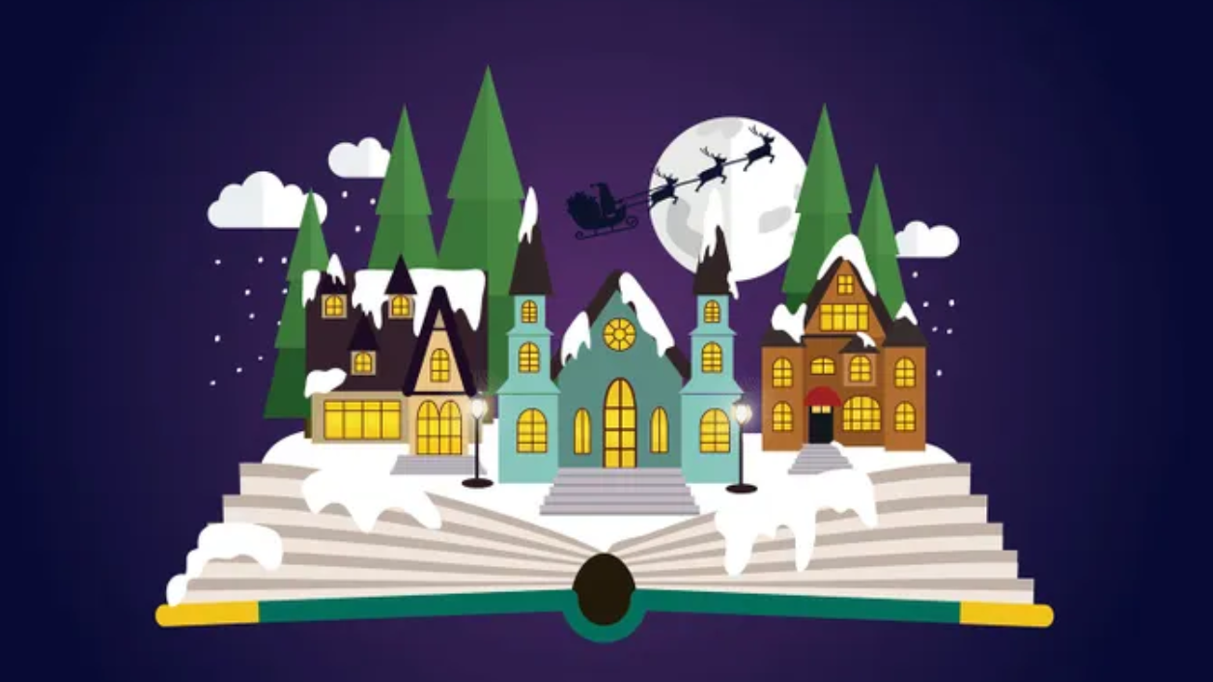 | Read a book about Christmas    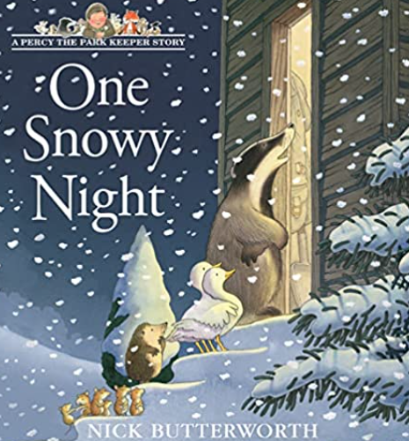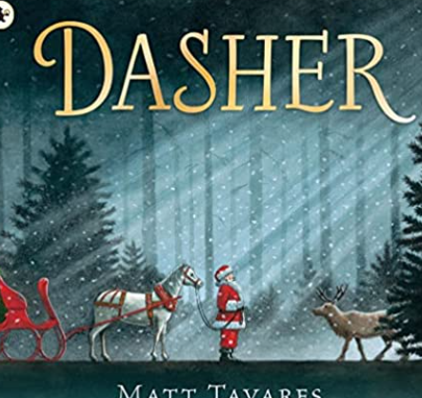 |  |  | Have a whole-family bedtime story    
Watch the film of a book: The Polar Express, Charlie and The Chocolate Factory, The Borrowers, Matilda and The Gruffalo are just a few good ones to look out for  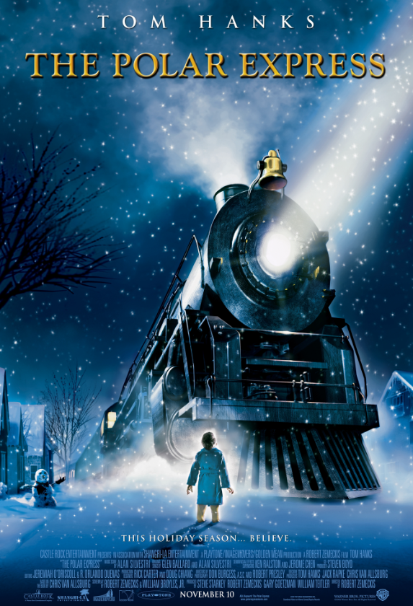 | 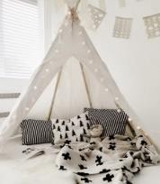  Make a family book nook |  |  | Read a book with a hot chocolate  
Share your pictures via your class teams or our facebook page.If you manage to complete your challenge bring your sheet in to Mrs Rayner for a special certificate.

